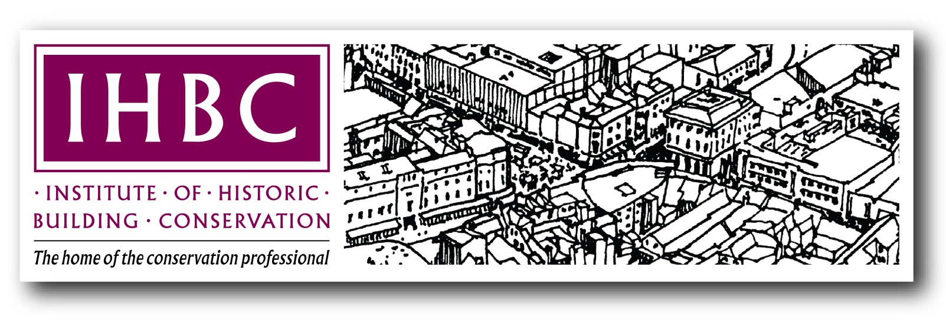

The Institute of Historic  
Building Conservation

Application Form

IHBC ASSOCIATE (Management)

*Demonstrating ‘competence in conservation-related work that manages change in the built and historic environment’*

Registered as a Charity in England: No. 1061593

Registered as a Charity in Scotland: No. SC041945

Company Limited by Guarantee; registered in England: No.3333780

Business Office: Jubilee House, High Street, Tisbury, Wiltshire SP3 6HA

Registered Office: 3 Stafford Road, Tunbridge Wells, Kent TN2 4QZ

**1. Introduction to the application**

* The Institute of Historic Building Conservation (IHBC) is a professional body and charity that supports skills in all aspects of the conservation and management of valued and historic places and fabric, including cultural areas, buildings, interiors and landscapes.
* To support conservation the IHBC offers ‘quality assurance’ by accrediting your skills in conservation-related practice.
* This form can be used to apply to become an Associate of the IHBC, as a practitioner who is competent in ‘managing change’ in the built and historic environment
* Associate membership is renewable every five years, with reminders provided by the IHBC
* Associate membership (Management) means that you may describe yourself as an ‘IHBC Associate, accredited for practice in conservation-related work that manages change in the built and historic environment’. *This text must be used to clarify your IHBC accreditation as an Associate in all relevant public statements. When abbreviating the description, as in business cards for example, please make clear that you are an Associate of the IHBC by referring to the category as follows:   
  ‘Jo Bloggs AssocIHBC’. DO NOT use ‘Jo Bloggs IHBC Associate’,or ‘Jo Bloggs, IHBC (Associate)’ or similar.*

AND BEFORE CONTINUING:

* Please use our on-line guidance at <http://www.ihbc.org.uk/join/Categories/index.html> to ensure that this membership type is the most appropriate for you
* Applicants should possess an IHBC membership number. You can register online at <http://ihbc.org.uk/machform/view.php?id=20> )
* Please read carefully the guidance identified below BEFORE completing this form
* Please include with your submission a current and full CV or comparable statement of experience to supplement your application.

**FORMAL STATEMENTS**

**All the information in this form is correct to the best of my knowledge**

**I have included a current, detailed CV or comparable register of experience**

**I agree to abide by the same terms specified in the Full Member application form** (<http://www.ihbc.org.uk/join/page29/index.html>)

Full Name: Affiliate No (as available):

Email:

*Insert Digital signature below OR put an x where indicated if you do not have one*

SIGNED: Alternative to Signature (enter x):

**1.1 Essential Guidance: Accreditation, Testimonials & levels of competence**

The IHBC accredits conservation skills, knowledge and experience at two levels:

• Associate: Accreditation in your primary area of competnce, renewable every five years

• Full Member: Accreditation across more than one area of practical competence.

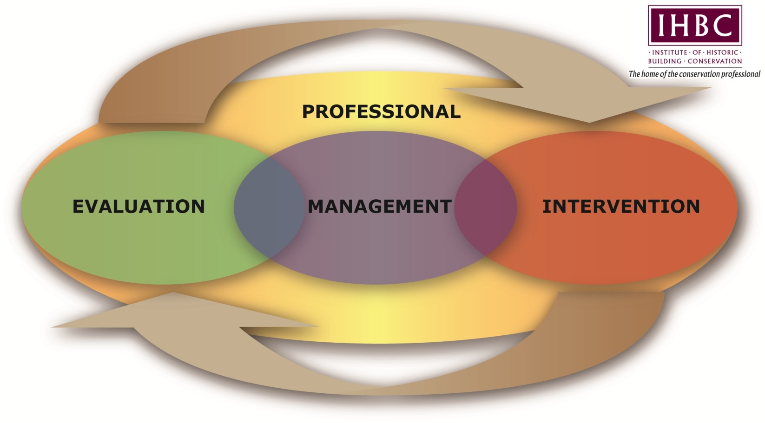IHBC accreditation is informed by your ‘Testimonial’, the statement of competence you make using this application form. Your Testimonial must effectively demonstrate and provide adequate evidence of, your skills, knowledge and experience in conservation practice. Your application will succeed ONLY when the IHBC assessors can clearly recognise an appropriate level of conservation competence in line with our models and standards, as noted below.

As conservation is most effective when disciplines work together, all Testimonials are made and tested in line with our Conservation Cycle. This Cycle aligns practice with four generic Areas of Competence: the overarching ‘Professional’ Area of Competence, and the three ‘Practical’ Areas: Evaluation, Management and Intervention.

The ‘Professional’ Area shapes and informs conservation advice and decisions, and is the most important and most challenging for applicants. The ‘Practical’ Areas cover key stages in conservation practice: Evaluating and Managing what is being conserved, and as appropriate generating change, or Intervention. These Areas represent generic activities that recognise mainstream practices within wider conservation skills sets as follows:

The IHBC’s model Conservation Cycle showing   
our four ‘Areas of Competence’

• Evaluation: reflecting cultural disciplines, for example history or archaeology

• Management: in place and asset-management, such as planning or project development

• Intervention: tied to development processes in architecture, engineering or urban design.

To help structure your Testimonial, our Areas of Competence are divided into pairs of Competences that reflect more specialist areas of conservation practice, as indicated below.

**Accreditation as an IHBC Associate requires demonstration through evidence of competence BOTH in the Professional Area of Competence AND in ANY ONE of the Practical Areas, AS WELL AS Awareness in the other two Areas of Competence**.

**DEMONSTRATE LEVELS OF CONSERVATION SKILLS, KNOWLEDGE AND EXPERIENCE**  
• ‘Competence’ is when you demonstrate adequate knowledge and skills, when you are able to work with some autonomy and in a team, if you may require further guidance

• ‘Awareness’ is when you demonstrate basic skills but may require supervision or training

*NB: Conservation combines flexibility with specialisms, so these modest generic descriptions require wide-ranging skills, a substantial knowledge base and a diverse experience of practice.*

**Further details available at** <http://www.ihbc.org.uk/membership_downloads.htm>

**2. Testimonial Guidance**

**2.1 Statement of qualifications, professional memberships and relevant experience**

Please enclose with your completed form a full, current CV or equivalent.

**2.2 Optional listing of 6 cases etc. to be used as evidence in your Testimonial**

*If you find it useful, please list up to 6 key projects, cases, or their equivalent, that you will refer to in your testimonial, noting that:*

* Additional summary evidence may be included as annexes.
* Cases listed may be used in more than one section of the testimonial
* The Professional Area of Competence is the most challenging, and must be demonstrated by all applicants, so always use your strongest evidence there.

1.

2.

3.

4.

5.

6

**2.3 Completing the Testimonial**

|  |  |
| --- | --- |
| **DO:** | **DO NOT:** |
| Be concise. | Do not repeat yourself, or affirm competence without offering evidence. |
| Use a computer or type your application. | Do not submit hand-written forms. |
| Be specific about your own conservation actions, responsibilities and outcomes. | Do not rely on job titles etc., or terms like ‘involved with’, without specifying your role. |
| Be explicit: You could say something like: 'My knowledge of the philosophy of conservation is based on a detailed understanding gained through conservation course training at the University of Westingham’s IHBC recognised conservation course [WEB LINK]. I have applied the conservation principles learned there most effectively in my contribution to the team that worked on the extension to the local library in Westingham village nearby (see Supporting Information Case 1, Illus. 1). Here the client had considered that a modern interpretation of the historic fabric would be more likely to succeed under planning policy. As the streetscape was characterised by diverse architectural styles of variable quality, when leading discussions with the Conservation Officer and planners I was able to introduce SPAB principles to justify... etc. | Do not refer only to your experience, for example as follows: 'Twenty years as a staff member in our national heritage agency, and ten as senior conservation officer leading a team of five, all rounded off with the recent successful completion of an IHBC-recognised conservation course, demonstrate categorically that I must be fully conversant with all aspects of conservation philosophy.'  OR: ‘See my attached portfolio for the £2m extension to the Grade I listed library that was supported by English Heritage and the local authority, and won 3 national awards. It was a challenging project, but it demonstrates effectively my informed and skilled approach to conservation and my professional dedication to, and command of, historic environment conservation.’ |
| Be clear in the evidence you use to support and inform cases and projects. Evidence MUST be verifiable, but all information does not need to be included. Reference to websites and other source material is useful if assessors want further detail, and can be included in relevant annexes. | Do not presume that inclusion of information on your work constitutes a demonstration of competence. Examples should make specific and explicit reference to an aspect of your work in the context of the competence under discussion, and be represented by case or project evidence. |
| Include an up-to-date IHBC CPD form or relevant log book of work or equivalent, as supporting evidence. | Do not just rely on your CV: information relevant to the testimonial should be included within the application. |
| Refer to your personal contributions and duties when evidence relates to team-work. | Do not refer generally to a team project without specifying your contribution. |
| Underpin your statements with verifiable project information, references and evidence, either in the text or annexes, but do not offer evidence or cases without explaining its relevance. | Do not forget that statements on your work are no more than anecdotes without supporting evidence, and assessors cannot use anecdotes to assess competence. |

**3. Testimonial**

**3.1 ‘Professional’ Area of Competence**

**Demonstrate your competence in Philosophy and Practice**

**PHILOSOPHY:**

**Appreciation of the social, cultural, political, aesthetic, economic and environmental values that underpin current conservation policy and practice, its history and its future.**

*Optional guidance – Please follow this structure only if it helps*

* Outline your understanding of the philosophy of conservation and how you gained it
* Review your knowledge of conservation philosophies to demonstrate that you are fully conversant with currently prevailing national and international principles and standards (ICOMOS, BS etc.) as well as new ideas shaping conservation, for example sustainability, climate change, equality and fiscal policies.
* Give two examples that demonstrate how you can interpret, negotiate within and apply different philosophies of conservation by describing:
* The situation, and who was involved
* The philosophies you deployed and why
* Your personal contribution and how you made a difference
* The outcome.

**Statement and Evidence**: *Enter your evidence for this section below, up to about 2000 words.*

**PRACTICE:**

**Understanding of the wider context of conservation and its professional practice, including knowledge of and ability to interact effectively with all bodies and individuals who have a significant role to play in the field.**

*Optional guidance – Please follow this structure only if it helps*

* Outline your knowledge of the practice of conservation in its wider contexts, such as business and project management, planning, regeneration, development, corporate and change management etc., and how you gained it.
* Give two examples that demonstrate your knowledge of the roles, responsibilities and potential of bodies relevant to historic environment management, referring for example to:
* Who was involved, and why, including relevant heritage roles and responsibilities
* Your precise role in implementing, managing and/or supporting conservation practice including also, for example, relevant wider standards for practitioners such as Health and Safety and Risk Management
* Your role in partnering, interaction and negotiation referring to, for example:
* community and amenity groups
* elected representatives
* owners, clients, applicants and officials
* seeking and advising on specialist and other professional advice
* What your personal contribution was in each case, and what were the conservation outcomes.

**Statement and Evidence**: *Enter your evidence for this section below, up to about 2000 words.*

**LEGISLATION AND POLICY:**

**3.2: ‘Management’ Area of Competence**

**Demonstrate your competence in Legislation and Policy and Finance and Economics**

**Knowledge of the legislative and policy framework for the conservation of the built and historic environment, its formulation and application in planning both locally and nationally and an awareness of other relevant legislation and policies alongside an understanding of the relationship between these and planning legislation and policy relating to conservation.**

*Optional guidance – Please follow this structure only if it helps*

* Outline how you gained your knowledge and understanding of conservation legislation and policy and its operation within the planning process.
* Using two distinct examples, demonstrate your knowledge of conservation legislation and policy, specifying for each:
* The example, including why and how you were involved, briefly covering issues such as, for example:
* Your role in advising or negotiating on conservation consent issues, or other relevant statutory consents and permissions, in the context of current legislation and central government advice, and/or
* Your application of guidance on current legislation, or of other legislation in so far as it affects the built and historic environment, including building regulations, planning and highways legislation, and/or
* Your experience of drawing up, implementing and/or monitoring conservation policies and strategies, and/or
* Your experience in acting as an expert witness
* How your involvement demonstrates your knowledge of legislative/policy processes in respect of these issues
* What you learned, and the conservation outcomes that you helped secure.]

**Statement and Evidence**: *Enter your evidence for this section below, up to about 2000 words.*

**FINANCE AND ECONOMICS:**

**Understanding of processes for procuring building or other historic environment works and facilitating appropriate management, development and regeneration projects, including finance, valuation, cost planning and contracts, with specific reference to historic buildings, landscapes, sites and areas.**

*Optional guidance – Please follow this structure only if it helps*

* Outline how you gained your knowledge and understanding of finance and economics as they relate to conservation processes.
* Use two examples to demonstrate your involvement with financial operations and economic matters relevant to conservation, specifying for each:
* The example, and why and how were you involved, briefly covering issues such as, for example:
* Your operation of and involvement with the economics of heritage management or regeneration projects, including the process of investment in conservation processes and the factors affecting them, as well as the workings of the property market and methods of valuation, and/or
* Your work with bodies responsible for heritage regeneration and sources of funding for it, referring as relevant to funding schemes not specifically aimed at conservation (eg National Lottery, European funding) as well as the administration of grant schemes, and/or
* Your ability to promote or generate investment in the built and historic environment, whether public or private, and/or
* Your involvement or familiarity with the operation of contractual aspects of conservation work including differing forms of contract, costing of conservation works and VAT
* How each example demonstrates your knowledge of heritage-related finance and economics

What you learned and how this made a difference to conservation.

**Statement and Evidence**: *Enter your evidence for this section below, up to about 2000 words.*

**DESIGN PRACTICE AND PRESENTATION:**

**3.3 ‘Intervention’ Area of Competence**

**Demonstrate your awareness in Design Practice and Presentation and Technology**

**Ability to analyse, evaluate and/or promote quality in design, existing and proposed, covering details, buildings and areas as well as rural and urban contexts, and to present and explain such quality in ways understandable to both professional and lay audiences.**

**Statement and Evidence**: *Enter your evidence for this section below, up to about 1000 words.*

**TECHNOLOGY:**

**Knowledge of building construction of all periods, the characteristics of structures, the nature and properties of building materials and appropriate methods of care, repair, alteration and improvement of historic fabric**.

**Statement and Evidence**: *Enter your evidence for this section below, up to about 1000 words.*

HISTORY:

3.4: ‘Evaluation’ Area of Competence

**Demonstrate your awareness of History and Research, Recording and Analysis and experience in these areas**

Knowledge of the history and development of a broad spectrum of the built and historic environment, including the heritage and development of previous cultures and periods as expressed across historic buildings and their details; settlements; urban areas; works of engineering; parks, gardens and other elements of the historic landscape, alongside more detailed knowledge of any specialist areas of interest.

**Statement and Evidence**: *Enter your evidence for this section below, up to about 1000 words.*

RESEARCH, RECORDING AND ANALYSIS:

Ability to carry out or commission research, analysis, survey and recording of the historic environment, and to maintain records accordingly.

**Statement and Evidence**: *Enter your evidence for this section below, up to about 1000 words.*

**3.5 Supporting information**

**Please provide here any other relevant comments or references to support your information. Include for example: completed CPD Forms; work logs that include relevant courses and/or lecture programmes; events you have attended; related professional specialist interests or voluntary roles such as involvement in the work of the IHBC; or relevant parts of other bodies.**

**Applicant’s Additional Evidence**: *Enter your evidence for this section below.*

**Endorsements of Application** *(To be filled in by persons endorsing application)*

**Endorsement from a Full Member of the IHBC**

I have read the IHBC Membership Application Form prepared by: and have discussed it with the applicant. I see no areas in this submission to become an Institute of Historic Building Conservation Associate that conflict with my knowledge of the candidate or their work.

Full Name of Sponsor: Membership No. of Sponsor:

*Insert Digital signature below OR put an x where indicated if you do not have one*

SIGNED: Alternative to Signature (enter x):

Date:

**Endorsement from Employer/Person with Knowledge of Applicant's Professional Knowledge and Experience**

I have knowledge of the professional experience of: and I have read this application and discussed it with the applicant. I consider the details to be a correct reflection of their professional knowledge/experience.

Full Name of Professional Sponsor:

Job Title:

Address of Employer Sponsor:

Email address of Employer Sponsor:

*Insert Digital signature below OR put an x where indicated if you do not have one*

SIGNED: Alternative to Signature (enter x):

Date:

**Applicant should email the completed form, together with CV and any supporting papers, to the IHBC Membership Services Officer** [membershipservices@ihbc.org.uk](mailto:membershipservices@ihbc.org.uk).