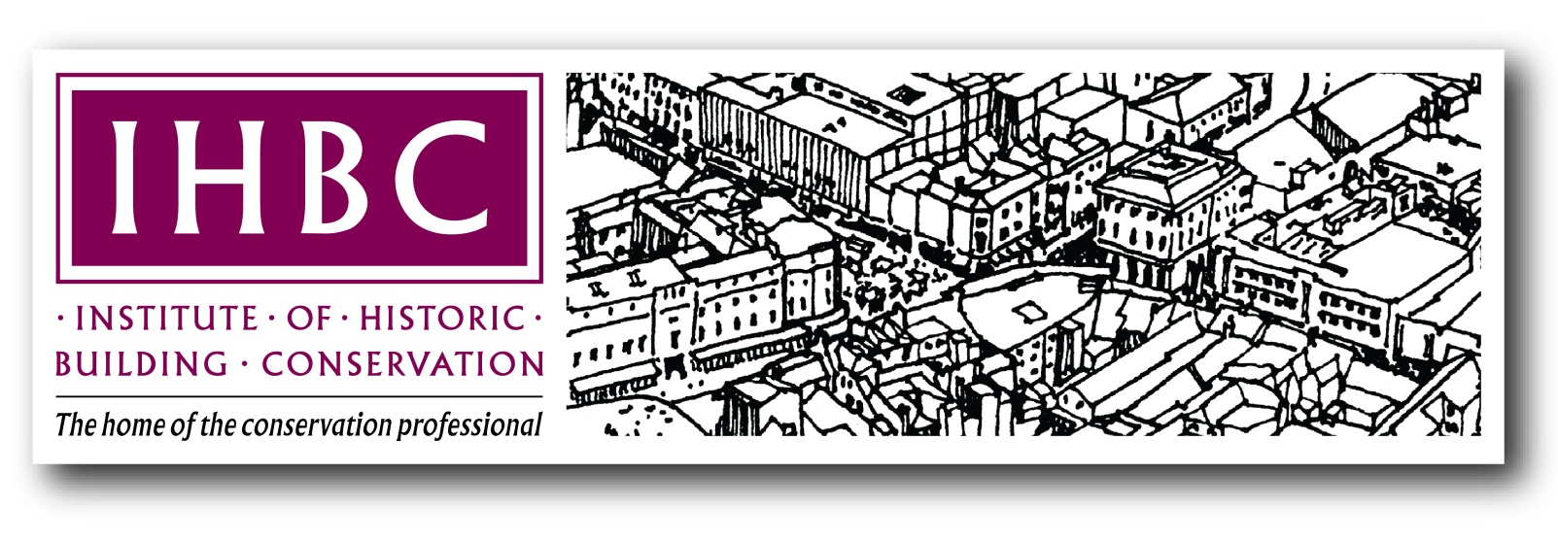

The Institute of Historic
Building Conservation
Full Member
and Associate
Application Form

Registered as a Charity in England: No. 1061593
Registered as a Charity in Scotland: No. SC041945
Company Limited by Guarantee; registered in England: No.3333780
Registered & Business Office: Jubilee House, High Street, Tisbury, Wiltshire SP3 6HA

BASIC GUIDANCE ON COMPLETING THIS FORM
- Please ensure you have completed the IHBC’s online Registration before continuing
- Please read carefully the guidance identified below BEFORE completing this form
- Please delete, add, tick, mark or specify as necessary throughout the form
- For Associate applications be sure to give most emphasis in your testimonial to work that represents your primary area of practice
- Affiliates seeking Associate membership only may prefer to use the dedicated Associate Application Form relating to their primary area of practice. See website for details.

Personal Details & Formal Statement
By submitting this application you are confirming that all the information in this form is correct to the best of your knowledge.
Full Name:
Affiliate or Associate No (if you are upgrading):
Email:
Telephone:
If you would like to be listed on the IHBC’s online and publicly accessible ‘database of IHBC accredited conservation practitioners’, please tick here: ☐

(NB: Associate members are automatically listed –see ihbc.org.uk/accredited/
Summary Guidance on the Application
This is the form to use when you apply to become a Full Member of The Institute of Historic Building Conservation (IHBC: ihbc.org.uk). It can also be used for Associate application though there are shorter forms available on our website that are dedicated to the different primary Areas of Practical Competence, which may be preferred. Accreditation from the IHBC is the recognised mark of professional competence in built and historic environment conservation. This is a lifetime commitment, to be maintained through continuing professional development (CPD).
It is the responsibility of the applicant to demonstrate competence. To help you demonstrate competence, please follow the guidelines and recommendations, paying particular attention to how to demonstrate abilities in the Testimonial (pages 7-15).
Where relevant, the IHBC’s Membership Secretary will recommend the membership category appropriate to your application, whether as Full Member or as Associate.
To help us register your application please ensure that you can TICK most or all of the boxes below, or your form may be returned with a request for further information.
1. | Before you complete this form please ensure that you:
 | Read, understand, and observe the summary in the guidance on pages 5-7 below as well as the ‘Guidelines’ at https://www.ihbc.org.uk/membership_downloads.html. Do not rely on the strengths evident, say, in your curriculum vitae, as a demonstration of your skills in the Testimonial. You may also find it useful to look at the resources carried on our website and the guidance on the website for built environment professional bodies at www.understandingconservation.org/.
 | When applying for full membership, you must demonstrate either the equivalent of at least five years of relevant conservation experience or the equivalent of two years of relevant post qualification experience if you have completed an IHBC-recognised conservation course. Training routes to professional membership are explained at https://www.ihbc.org.uk/join/page32/index.html.
 | If possible please review your application with IHBC members and other colleagues. IHBC Branches maybe able to help: links are listed at https://www.ihbc.org.uk/branches/index.html
 | Consider carefully the range of cases and projects that can represent your work across different areas of conservation, in line with our guidance and recommendations.
2. | Then you may also want to:
 | Complete the IHBC’s CPD forms and/or a log of work, either of which would be useful to help you complete your application and may be suitable for submission in support of your application. For CPD guidance and forms see: https://www.ihbc.org.uk/learning/cpd/index.html.
 | When completing this application form ensure that you:
 | Allow sufficient time to prepare the application, note that deadlines for applications are identified at https://www.ihbc.org.uk/join/apply/index.html.
NB: For each of the IHBC’s eight Competences an application should be supported by two cases or projects, each of which should be about half a page long. Examples must be appropriate and concise. Supporting information including references that might allow for independent verification as required, such as address; web site; bibliographic details etc should be included.
Ideally, at least two of the cases should have sufficient complexity to allow for the demonstration of a number of Competences. Overall it is recommended that you use between six and eight case studies to illustrate your competencies, Supporting information, including project drawings, specifications etc., should be concise and relevant to the assessment.
You can use this form to apply for accreditation as an Associate. Please follow the general guidance but be sure to give most emphasis in your testimonial to those areas that represent your primary area of practice. Alternatively, use the separate forms tailored for Associate applications.
 | While you may wish to refer to individual cases across the Testimonial, take care to avoid repetition of particular examples intended to demonstrate competence.
 | Be sure to explain in your testimonial what you know, how you gained this knowledge (through what educational course, practical experience etc.), and use examples from cases to show how you have applied that knowledge. You should also be able to refer to suitable conservation outcomes. Note that any plagiarism is wholly unacceptable and will lead to refusal.
 | Acknowledge openly any Competences in which you may have less experience. Remember that you are not expected to be skilled in respect of every Competence (see page 8).
Clarify the input of other professionals in your cases, and make clear your own contribution.
If you wish to use text from another source, make sure it is appropriately referenced
 | Reflect on your completed application form so as to ensure that it demonstrates your skills effectively and in line with our guidance as assessors are unlikely to be familiar with your work.
 | Sign the Declaration at the end of this application form and observe payment arrangements.
4. | And remember that, by submitting your completed form, you accept that:
 | You agree to abide by the IHBC’s application and assessment procedures and standards.
 | The relevant Branch will receive the application for review, so while we maintain reasonable confidentiality, your application will be seen by peers outside the Membership Committee.
 | Failure to secure recommendation as a Full Member of the IHBC does NOT infer a lack of professional skills on your part.
 | Our response will take an absolute minimum of four months from receipt, and sometimes much longer, especially if additional information is sought.
 | All payment must be received prior to processing an application.
 | Unsuccessful applicants who are not already IHBC members will be encouraged to become Affiliate or Associate Members. This helps us to promote professional development in line with the IHBC’s charitable objectives and to support the applicant in future submissions.

Summary Guidance on the Testimonial
Your Testimonial (page 9 on) must demonstrate to the IHBC’s assessors your skills, knowledge and experience in built and historic environment conservation.
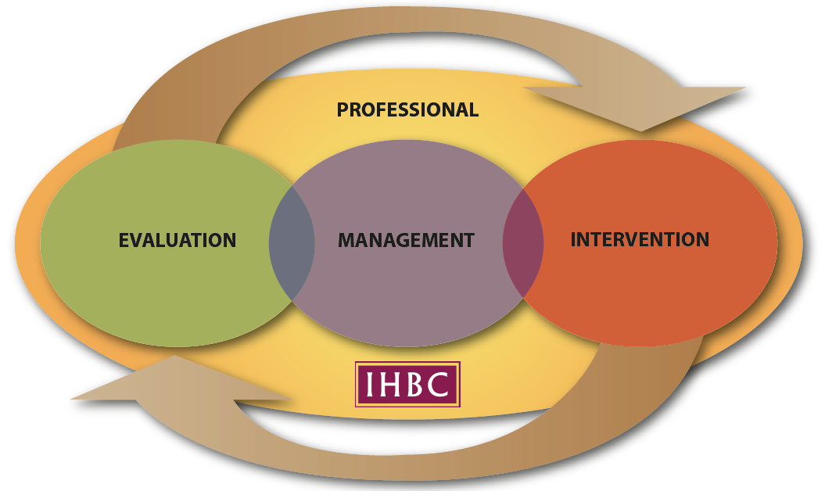
Both Full and Associate membership of the IHBC demand a demonstration of competence across the range of specialist skills, knowledge and experience that underpin conservation outcomes in accordance with international standards. The IHBC’s four Areas of Competence, as represented in the conservation cycle below, represent members’ inter-disciplinary skills – the overarching ‘Professional’ Area of Competence, and the three Practical Areas: ‘Evaluation’, ‘Management’ and ‘Intervention’.
Figure 1: The IHBC’s model Conservation Cycle and our four ‘Areas of Competence’

The Professional Area of Competence informs and shapes conservation advice and conclusions and is the most important. Applicants for BOTH Full and Associate membership MUST demonstrate substantial abilities in the Professional Area of Competence to secure accreditation from the IHBC.
The Practical Areas of Competence, of Evaluation, Management and Intervention, correspond respectively to cultural disciplines such as history or archaeology; to ‘place management’ and regeneration specialisms such as planning; and to design and technical solutions provided in architectural, engineering, urban design and project management disciplines (https://www.ihbc.org.uk/join/applicant_guidance/index.html). As conservation demands extensive overlap between these Practical Areas of Competence, strengths in one Area may compensate for more limited experience in others.

Assessing Skills
The IHBC’s four Areas of Competence each comprise two Competences, as shown below:
Areas of  Competence | Professional | Practical  Evaluation | Practical  Management | Practical  Intervention
Competences | 1. Philosophy  2, Practice | 3. History  4. Research,  Recording and  Analysis | 5. Legislation and  Policy  6. Finance and  Economics | 7. Design and  Presentation  8. Technology

In accordance with the skills table below, applicants for FULL MEMBERSHIP must demonstrate at least a ‘Capable’ level in the ‘Professional’ Area of Competence AND in at least TWO of the ‘Practical’ Areas of Competence. They must also be at least be Aware’ in the third ‘Practical’ Area of Competence.
Applicants for ASSOCIATE MEMBERSHIP must demonstrate at least a ‘Capable’ level in the IHBC’s ‘Professional’ Area of Competence, AS WELL AS in at least ONE of the ‘Practical’ Areas of Competence. In addition, they must beat least ‘Aware’ in the other two ‘Practical’ Areas of Competence.
Assessing competence: (see CPD Certification Service http://www.cpduk.co.uk/index.html)
Unaware | Aware | Capable | Skilled | Expert
unaware of subject area  possess little or no knowledge/ skills  require full training and development | possess basic knowledge/ skills  unable to work without supervision  require training/ development and more in-depth information | possess adequate knowledge/skills  able to work with some autonomy  able to work effectively as part of team  require guidance/some further training | possess requisite knowledge/skills to perform effectively and efficiently  able to work with considerable autonomy  need occasional top-up training | acknowledged by others as an authority  very substantial personal autonomy

Applicants seeking more detail on the process may request templates of assessment forms from the IHBC’s national office by emailing membershipservices@ihbc.org.uk.
When completing your Testimonial:
DO: | DO NOT:
Remember that being concise is a strength, so please limit you application to between two and four A4 typed pages per area of competency (ie between 16 and 32 pages overall). | Do not feel restricted by the pages as fields expand to accommodate text. Illustrations and drawings can be appended separately if required.
Use a computer or type your application. | Do not handwrite forms.
Specify conservation actions, responsibilities and outcomes. | Do not simply re-state your titles or appointments OR use terms like ‘involved with’ without clarifying your role.
Be explicit: You could say something like:  'My understanding of the philosophy of conservation is based on a detailed understanding gained through my conservation course training at XXXX college, which constituted a full module. I have applied the principles explored there most effectively in my contribution to the team working on the extension to the local library (see Supporting Information Case 1, Illus. 1).’  In this example the applicant considered that a modern interpretation of the historic fabric would be more likely to succeed under planning policy. As the streetscape was characterised by diverse architectural styles of variable quality, and the original submission tended towards a sub-classical pastiche, I was able to refer to SPAB principles of clearly distinguishing old and new works to make the case for a more assertive high-quality modern intervention, with the result that... etc. | Do not refer only to your experience, for example:  'Twenty years as a staff member of the national heritage agency and ten as senior conservation officer leading a team of five in private practice, rounded off with the successful completion of an IHBC-recognised conservation course, together demonstrate that I am fully conversant with all aspects of conservation philosophy.'  OR: ‘See my attached portfolio for the £2m extension to the Grade I listed library which was supported by English Heritage and the local authority, and won 3 national awards. It was a challenging project, but I believe it demonstrates effectively my informed and skilled approach to conservation and my professional dedication to, and command of, historic environment conservation.’
Be concise and specific in the evidence you use to support and inform cases and projects. Evidence MUST be verifiable, but all information does not need to be included in the submission. Reference to websites and other source material is useful if assessors want further detail. | Do not use an entire case (such as an article or building portfolio) without considering its value to the assessment. All examples should make specific and explicit reference to an aspect of your work, represented by case or project evidence. Also do not simply refer to a digital ‘flat-pack’ of information: ‘My Masters dissertation in conservation philosophy confirms my command of its principles (attached, & apologies for the 50MB file).’
Use an up-to-date IHBC CPD form or relevant log book of work, if you have one, as supporting evidence. | Do not simply submit a CV, as relevant information there should be included within the application form.
Where using cases involving working with a team, be sure to refer to your specific roles and duties. | Do not either plagiarise or refer generally to a team project without specifying what your contribution was to any outcome.
Delete the above guidance notes (pages 1 to 9) from your submission. Please start your application with page 10 below. | Do not include the guidance notes.
Educational Qualifications
Where applicable, please enter details of each qualification as follows: NB Please give highest qualification first and allow a line space between each.
Title of qualification:
(eg Master of Arts/ National Vocational Qualification Conservation level 6)
Designatory letters (eg MSc):
Granting body: (eg Plymouth University/ Awarding Body of the Built Environment (ABBE))
Full time or Part time:
Date of commencement and completion (eg 1993-1995):

Current Professional Membership(s)
(i.e. where skills have been tested prior to entry)
Give full title of all professional qualifications & normal abbreviations
(eg Member of the Royal Institute of British Architects (RIBA)) to include:
Name of professional body:
Title and abbreviation of professional qualification:
Date of election or equivalent:

Relevant Experience
Please email a copy of your full CV together with this completed form.
If you do not have a CV please provide full details for each period of relevant employment or voluntary experience (current or most recent first, allowing a line space between each) as follows:
Name and address of employer/experience provider:
Field of employment:
Job description and duties:
Dates:
Testimonial
Area of Competence: Professional
1 PHILOSOPHY: ‘Appreciation of the social, cultural, political, aesthetic, economic and environmental values that underpin current conservation policy and practice, its history and its future.’
Optional Guidance – Please follow this structure only if it helps
- Outline your understanding of the philosophy of conservation and how you gained it
- Review your knowledge of conservation philosophies to demonstrate that you are fully conversant with currently prevailing national and international principles and standards (ICOMOS, BS etc.) as well as new ideas shaping conservation, for example sustainability, climate change, equality and fiscal policies.
- Give two examples that demonstrate how you can interpret, negotiate within and apply different philosophies of conservation by explaining:
- What was the situation and who was involved?
- What philosophies did you deploy and why?
- What was your personal contribution and how did you make a difference?
- What was the outcome?

Enter your evidence for this section below.

2. PRACTICE: ‘Understanding of the wider context of conservation and its professional practice, including knowledge of and ability to interact effectively with all bodies and individuals who have a significant role to play in the field.’
Optional Guidance – Please follow this structure only if it helps
- Outline your knowledge of the practice of conservation in its wider contexts, such as business and project management, planning, regeneration, development, corporate & change management etc., and how you gained it.
- Give two examples that demonstrate your knowledge of the roles, responsibilities and potential of bodies relevant to historic environment management, referring for example to:
- Who was involved, and why, including relevant heritage roles and responsibilities
- Your precise role in implementing, managing and/or supporting conservation practice including also, for example, relevant wider standards for practitioners such as Health and Safety and Risk Management
- Your role in partnering, interaction & negotiation referring to, for example:
- community and amenity groups
- elected representatives,
- owners, clients, applicants & officials
- seeking and advising on specialist and other professional advice
- What your personal contribution was in each case, and what were the conservation outcomes?

Enter your evidence for this section below.

Area of Competence: Practical – Evaluation
3. HISTORY: ‘Knowledge of the history and development of a broad spectrum of the built and historic environment, including the heritage and development of previous cultures and periods as expressed across historic buildings and their details; settlements; urban areas; works of engineering; parks, gardens and other elements of the historic landscape, alongside more detailed knowledge of any specialist areas of interest.’
Optional Guidance – Please follow this structure only if it helps
- Outline how you gained your knowledge and understanding of history, referring both to your education in, and your experience of evaluating the character or significance of, or special interest in, historic sites, structures, buildings and areas.
- Use two examples that demonstrate your knowledge of history, historical processes, periods, or areas, specifying:
- Why and how you interpreted historical fabric, values and significance, including through visual and archival investigation, and your conclusions
- How you applied your knowledge to inform conservation advice, for example through contributing to understanding cultural values, designation or other heritage management processes
- If relevant, how your assessment shaped development proposals.

Enter your evidence for this section below.

4. RESEARCH, RECORDING & ANALYSIS: ‘Ability to carry out or commission research, analysis, survey and recording of the historic environment, and to maintain records accordingly.’
Optional Guidance – Please follow this structure only if it helps
- Outline your involvement with research and/or related interpretation, recording, documenting, survey and analytical processes relevant to conservation, and how you gained that knowledge.
- Specify two distinct examples (e.g. a rapid and emergency recording, and a programme of detailed recording of structures) that demonstrate your experience of conservation research, recording and analysis, referring to:
- How each example demonstrates your knowledge of the processes, for example through advising on appropriate techniques and levels of recording and/or identifying the most appropriate bodies or individuals to undertake such work and/or manage its outcomes
- Where and why you have applied relevant techniques yourself, including written analysis, photographic and graphic representation (conventional and/or digital drawing techniques)
- How you have applied the knowledge to underpin conservation processes, for example through information or data management and archiving, or secure conservation outcomes, for example in shaping development projects, specifying what you did and how it helped serve conservation.

Enter your evidence for this section below.

Area of Competence: Practical – Management
5. LEGISLATION & POLICY: ‘Knowledge of the legislative and policy framework for the conservation of the built and historic environment, its formulation and application in planning both locally and nationally, and an awareness of other relevant legislation and policies alongside an understanding of the relationship between these and planning legislation and policy relating to conservation.’
Optional Guidance – Please follow this structure only if it helps
- Outline how you gained your knowledge and understanding of conservation legislation and policy and its operation within the planning process.
- Using two distinct examples, demonstrate your knowledge of conservation legislation and policy, specifying for each:
- The example, including why and how were you involved, briefly covering issues such as, for example:
- Your role in advising or negotiating on conservation consent issues, or other relevant statutory consents and permissions, in the context of current legislation and central government advice, and/or
- Your application of guidance on current legislation, or of other legislation in so far as it affects the built and historic environment, including building regulations, planning and highways legislation, and/or
- Your experience of drawing up, implementing and/or monitoring conservation policies and strategies, and/or
- Your experience in acting as an expert witness
- How your involvement demonstrates your knowledge of legislative/policy processes in respect of the issues
- What you learned, and what conservation outcomes you helped achieve.

Enter your evidence for this section below.

6. FINANCE & ECONOMICS: ‘Understanding of processes for procuring building or other historic environment works and facilitating appropriate management, development and regeneration projects, including finance, valuation, cost planning and contracts, with specific reference to historic buildings, landscapes, sites and areas.’
Optional Guidance – Please follow this structure only if it helps
- Outline how you gained your knowledge and understanding of finance and economics as they relate to conservation processes.
- Use two examples to demonstrate your involvement with financial operations and economic matters relevant to conservation, specifying for each:
- The example, and why and how were you involved, briefly covering issues such as, for example:
- Your operation of and involvement with the economics of heritage management or regeneration projects, including the process of investment in conservation processes and the factors affecting them, as well as the workings of the property market and methods of valuation, and/or
- Your work with bodies responsible for heritage regeneration and sources of funding for it, referring as relevant to funding schemes not specifically aimed at conservation (e.g. National Lottery, European funding) as well as the administration of grant schemes, and/or
- Your ability to promote or generate investment in the built and historic environment, whether public or private, and/or
- Your involvement or familiarity with the operation of contractual aspects of conservation work including differing forms of contract, costing of conservation works and VAT
- How each example demonstrates your knowledge of heritage-related finance and economics
- What you learned and how it achieved conservation outcomes.

Enter your evidence for this section below.

Area of Competence: Intervention
7. DESIGN PRACTICE & PRESENTATION: ‘Ability to analyse, evaluate and/or promote quality in design, existing and proposed, covering details, buildings and areas as well as rural and urban contexts, and to present and explain such quality in ways understandable to both professional and lay audiences.’
Optional Guidance – Please follow this structure only if it helps
- Specify how you gained your knowledge and understanding of design, new and old, in culturally sensitive and/or historic places, referring in particular to your ability to communicate, interpret and promote appropriate change among diverse audiences:
- Use two examples to demonstrate your knowledge and experience of design in culturally sensitive contexts, briefly covering issues such as, for example:
- Your informed appreciation, analysis of and/or proposals involving design for change, including casework, referring as required to technical, landscape, townscape and urban design principles, and/or
- Your communication of design concepts by means of sketching, conventional drawing or digital techniques in illustration, representation and/or interpretation, and/or
- Liaison, communication and consultation with clients, audiences and interest groups on change issues, and the re-interpretation of responses to inform design and other solutions, and/or
- Your contribution to the promotion of high standards of design of details, buildings or areas, by drawing up and implementing schemes and/or preparing design guidance/briefs, and/or
- Area enhancement, including urban design and landscape works and/or
- Design intervention in traditional or historic buildings
- For each example, explain why and how were you involved; how it demonstrates your engagement with these processes; what you learned and what was the conservation outcome.

Enter your evidence for this section below.

8. TECHNOLOGY: ‘Knowledge of building construction of all periods, the characteristics of structures, the nature and properties of building materials and appropriate methods of care, repair, alteration and improvement of historic fabric.’
Optional Guidance – Please follow this structure only if it helps
- Outline how you gained your knowledge and understanding of building construction and related technology, referring to a wide range of types and methods.
- Use two examples to demonstrate that knowledge and experience, referring for example to:
- Your role in advising on appropriate methods for the repair and maintenance of historic buildings or fabric, briefly covering issues such as, for example:
- Specialist repair techniques and the availability of materials and skills locally and nationally, and/or
- Physical and chemical characteristics of materials and causes of decay or deterioration, and/or
- Assessing and monitoring the condition of buildings, structures or sites, diagnosing threats or defects and specifying and prioritising proposals for their repair, maintenance and improvement, and/or
- Rapid and more detailed assessments of building conditions, including Buildings or Heritage at Risk Surveys, and/or
- Auditing and monitoring the general condition of fabric within areas, with a view to formulating and/or implementing strategies for action, and/or
- Advising on new and developing techniques in conservation and their practical implications.
- For each example describe the work and why and how were you involved, referring to how it demonstrates your experience of these processes and what you learned, including how you achieved desirable conservation outcomes.

Enter your evidence for this section below.

Any other relevant comments or references to support information, including for example completed CPD Forms, work logs that include relevant courses and/or lecture programmes, events you have attended, related professional specialist interests or voluntary roles such as involvement in the work of the IHBC, or relevant parts of other bodies, etc.
Begin typing below.

Endorsements of Application
NB: To be completed by the sponsors. Please copy and complete the text below and send it by email to membershipservices@ihbc.org.uk, copied to the applicant you are endorsing.
Endorsement from a Full Member of the IHBC
I have read the IHBC Membership Application Form for: and have discussed it with the applicant. I see no areas in this submission to The Institute of Historic Building Conservation that conflict with my knowledge of the candidate or their work.

Full Name of Sponsor: Membership No. of Sponsor:

Endorsement from Employer/Person with Knowledge of Applicant's Professional Knowledge and Experience
I have knowledge of the professional experience of: and I have read this application and discussed it with the applicant. I consider the details to be a correct reflection of their professional knowledge/experience.
Full Name of Professional Sponsor:
Job Title:
Address of Professional Sponsor:
Email address of Professional Sponsor:

Note to Applicants: It is your responsibility to ensure your endorsers have emailed their support for your application BEFORE you email your completed form, together with any supporting papers, to the IHBC Membership Services Officer membershipservices@ihbc.org.uk

