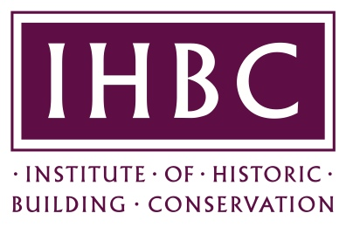
IHBC Northern Ireland Branch
Annual General Meeting
Tuesday, 7th November 2017 – 5.15 pm
UAHS, Old Museum Building, 7 College Square North, Belfast BT1 6AR

AGENDA

1.0 Present
2.0 Apologies
3.0 Minutes of previous AGM
4.0 Chair's report
5.0 Treasurer’s report
6.0 Election of Branch Officers
7.0 Any other business
8.0 Date of next AGM

