

IHBC EAST MIDLANDS BRANCH MEETING

Tuesday 7th July 2020
At: Zoom/Teams

MINUTES

Attendees:
Alice Ullathorne Chris Perkins Emilie Wales Carol Heidschuster
Roy Lewis Kerry Walmsley Jason Mordan Liz Mayle

- Apologies:
Chloe Oswald Rebecca Waddington Ros Worrall
Matt Bentley Vicky Mellor
Peter Chowns Rose Thompson Mark Sommerfield
Paul Grundy Sera Barker

- Minutes of the Last Meeting & Matters Arising
No applicants for the virtual school bursary so will be rolled over to next year.

EW/AU to include on AGM agenda/business case.

- Chair’s Report & Business Plan
Odd times means not quite what we planned in the business plan.

- September AGM (written report vice chair)
Weary of having a physical meeting for losing venue deposits or poor weather for outside. With a heavy heart, go for a virtual meeting.
Afternoon followed by chit chat and fun maybe quiz. Include CPD.
RW/CP come up with a date early/mid September.

- Virtual CPD (at AGM and afterwards)
15min to iron out IT Problems - 30min AGM – 2X 15 CPD presentations + 15minutes Q&As – social (if we use zoom can be recorded)

Topics
- Removal of Statues
- Covid and urban design recovery
- Bennerley viaduct – short presentation with later bike tour.

RT/JM/RW arrange speakers (Kieran?)
EW nominations 1 month in advance to be handed in 2 weeks before

  - Thermal Imaging
We would like to have it, but prefer to give him a physical slot. Small audience at uni with Alice filming with others tuning in.

  - Any other suggestions?
See topics above. Clumber park bridge and Wingfield Station possible future venues when physical meetings can resume.

EW/AU to include in AGM/business plan.

- Treasurer’s Report
No more statements since last meeting. £650 from central has been requested.

Current £1448.33 Reserve £191.01 Total £1639.34
After (expected) income £2554.34

  - Mynors Fees
LM and AU have got to the bottom of this, £65 went to central and has now been recharged. Remaining ones have been chased and expected soon.

  - Signatories
To be used as evidence when submitting documents for change of signatories. It is recorded as part of these minutes that the East Midlands Branch committee tonight agree to remove Rob Walker and David Boyson as signatories, and replaced them with Alice Ullathorne (Treasurer), Liz Mayle (Chair) and Emilie Wales (Secretary). These will all become Authorised Signatories, effective as of 07/07/2020. This meeting also heard that the accounts address would be changed to Alice Ullathorne, Nottingham City Council, Loxley House, Station Street, Nottingham, NG2 3NG.

AU send EW account details
EW/LM/AU complete forms

- Update on virtual annual school.
Interesting. Tiring looking at a screen for 2 hours no break. Did take notes which were useful, off topic BLM was good and relevant. Given speed of arrangement it was ok but poor substitute as missed social interaction.

Off topic RL (lots going on right now) - Dill appeal - GPA report – worrying HE response to BLM - Cummings wants to replace planning with zoning – government grants for energy efficiency – Covid changes to PD such as upwards development.

- Branch Reps Report
Policy committee next Tuesday and another Wednesday.

- Membership Report
New full member app. Members who know them asked to write to JM in support.

LM to send new member letters.

- County Rep’s Reports
Leicestershire – no update
Lincolnshire – Petersons was successful £1m funding AHF and NLHF – TH been helped by covid more people time to apply.
Nottinghamshire – Mansfield cracking on with enforcement, TH trickling in – Nottingham HAZ around Corn Exchange and Whitehart area HAZ ongoing – clumber bridge is repaired in Bassetlaw (twitter+ or future CPD??). No CO meeting.
Derbyshire – written reports.
Northamptonshire – no update.

- Communications (written report)
Many thanks from Chair to Vicky and Kerry for all their work.

  - Bulletin/Twitter
KW idea to request more project updates from county’s to show on twitter. Not from RL to make sure posts not case work or political.

AU to include requirement for bulleting regularly in business plan.

  - Website
Take more photos of events and be more vocal, especially now we aren’t getting out and about.

- Any Other Business
  - New venue
Wait to AGM, organ grinder may reopen – next meeting will be mid-October.

- Date of Next Meeting
Physical vs virtual AGM? – see how things progress.
Written Reports

Vice Chairs Report
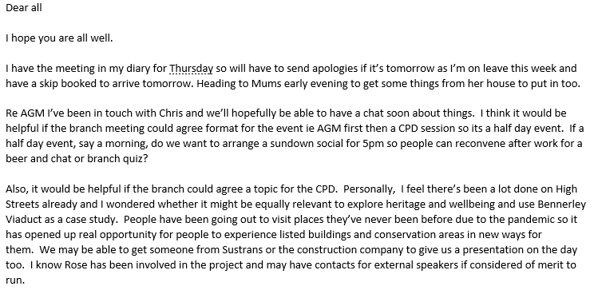

Derbyshire

Heritage at Risk Funding Update

Following the unfortunate news in March that our application to the National Lottery Heritage Fund (HF) for the Buildings @ Risk survey project had been unsuccessful we had received further feedback from the HF:
This outlined that we are being encouraged to re-apply for the development stage of the project as a single stage application, for which there are rolling deadlines and only an 8 week assessment process. They felt that the pilot activities in Erewash offered good potential.
The members of the HF were supportive of the project generally and considers it a good project. It needs to demonstrate better its lasting legacy beyond being a planning tool.
Applications of up to £250k are decided upon by the HF Head of Investment.
Since receiving the feedback, the impact of Covid-19 has meant that all HF’s standard grant programmes have been suspended. This means we are, therefore, unlikely to be able to submit an application before October 2020 at the earliest.
HER Update
AL reported that DCC are currently in the process of making the HER more accessible to everyone, which includes improving the website so that it is easier to search.
Funding applications and approvals/ Appeal decisions and case work
Wingfield Station (LG)

DHBT has been successful in securing a grant from Historic England from their 'Repair Grants for Heritage at Risk' scheme. This funding will allow us to undertake urgent repair work sooner rather than later; ensuring any further degradation to the Station and Parcel Store is halted in good time.
The first phase of the grant (£20k) is for development project costs relating to the preparation of architectural plans for re-roofing and essential trackside works, surveys and the preparation of the capital works tender documentation.
For the second phase, we have an in-principle grant offer of £243k towards eligible repair costs. This amount will be confirmed once we have satisfactorily completed the project development work and when the procurement process indicates the exact costs required. Historic England and others will work closely with DHBT to agree the overall conservation approach to the buildings.
Repair work will include the erection of scaffolding to the west elevations (plus the significant associated costs to Network Rail for possessions and related admin); roof works to the Station and Parcel Store (including roof coverings and the removal, repair and replacement of chimney stacks); stonework repairs to the western elevations; window and door replacements and repairs on the western elevation; the repair or replacement of rainwater downpipes; the removal of all rotten internal lintels and works to improve the access to the driveway, including tree and vegetation removal and improvements to visibility splays.
Our current timetable anticipates the submission of our Planning and Listed Building Consent applications by the end of August. We then hope to go out to tender for the construction works in October. All being well, this should then lead to the repair works starting during Spring 2021 and concluding by June 2021.
Our existing National Lottery Heritage Fund project is still very much progressing in parallel with this programme. Indeed, it is providing match-funding for some of the Historic England repair works along with professional fees and some of the survey costs. The only change as a result of this news is that we now intend to submit our second round application to the Heritage Fund in June 2021 (once the repair works are complete) instead of November 2020. The second round application to the Heritage Fund will cover the rest of the conservation and repair works along with other associated project costs. We will still need to raise additional funds to contribute towards the remaining costs of the project.
In other project news, an application has been lodged with Amber Valley Borough Council for consent to remove the yew hedge and self-seeded saplings in the immediate proximity of the station buildings. This work is necessary to enable the full topographical and building recording surveys to be undertaken at the earliest possible date.
We are hoping to get the front of the station area scraped/cleared back to enable a better understanding of the setting and we will also be scaffolding the internal and external areas of the building to allow various inspections to take place (Architectural Paint Analysis, roof survey, timber survey etc).
We are working with Activity Planners DBA to think about who our stakeholders are and how we are going to engage with them (especially during this period) and with G+ Studio, who will be producing creative interpretation in and around the site. Both consultants are going to be joining in a virtual meeting with the SW Local History Group later on this month. Mel Morris Conservation has been appointed as a Heritage Consultant and has been doing some great work revealing the importance of the site to help form the Conservation Philosophy.
Overseal House
T.G.Green’s Pottery Factory, Church Gresley
DL suggested that the bottle kilns (4 x Grade II*) should now go on DHBT’s list of priority buildings at risk.
PDNP is currently collecting the data on B@R - includes two Grade II* in Staffs (DL confirmed that the Staffordshire Moorlands are part of our project area with the B@R wider survey). One is the Critchlow Memorial, Sheen - https://historicengland.org.uk/listing/the-list/list-entry/1374551
The Bath House, Bakewell (RW)
Listed Building Consent granted with Conditions.

Appeals Update:
RW reported on a recent appeal:
Appeal APP/M9496/D/19/3240447 (design related / non-designated heritage asset) - https://acp.planninginspectorate.gov.uk/ViewCase.aspx?caseid=3240447

Branch Reps
Last meeting 28th May. Next meeting next Wednesday.
Draft minutes included:
- Agreeing to postponing annual school 2020 and having virtual instead.
- Dill supreme court case
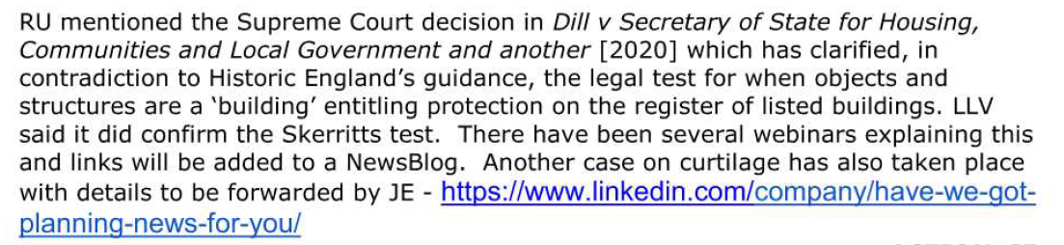
- Looking at covid themed task group
- 20% drop in subscriptions from last year to date (possibly covid related)
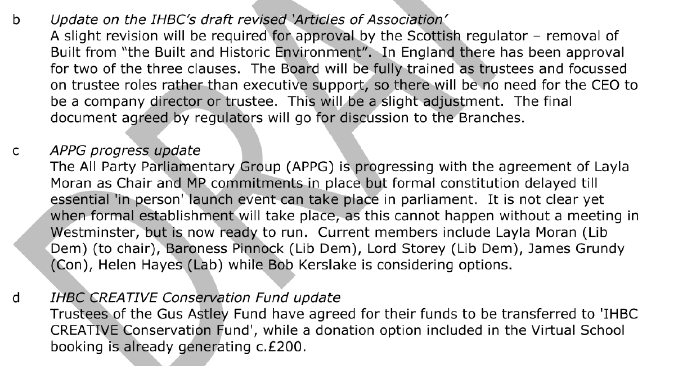
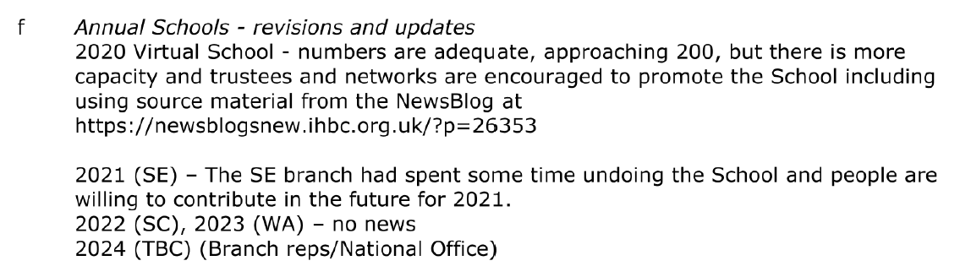
- IHBC ALGAO MOU agreed
We are pleased to announce the following news items on the ALGAO website
firstly a statement on the recent announcements regarding planning reform in England
https://www.algao.org.uk/news/statement-recent-proposals-reform-planning-system
and secondly, as mentioned in the recent ALGAO AGM , the MOU between ALGAO and the IHBC can now be circulated
https://www.algao.org.uk/news/algao-uk-and-ihbc-announce-memorandum-understanding

The Organ Grinder have also laid off their staff and will not be re-opening any time soon so we may have to consider an alternative venue for meetings if /when they resume.

Comms
Thanks to all those members of the committee who have patiently helped us with all of our queries in starting our new post. You will see that we have published a bulletin that went out to all east mids members and will look forward to receiving a steer on content from members after the July meeting. In line with the business plan our next step is to get twitter up and running with regular updates and we are working on the county updates where we hope to put on interesting information/websites and photos of some of the up and coming projects in the region. If members have any interesting projects, information, pictures anecdotes showing the amazing conservation practice in the region please send across to us. With personal and work circumstances changing so much for our members we would like to keep them up to date and feel twitter is an easier and more appropriate avenue for small updates. If there is anything else that needs updating or further communications please let us know. We also look forward to updating members on the details of the September AGM. Kerry and Vicky

Thermal Imaging

Morning Roy (and Emilie)

The world has indeed changed! But for me, strangely, it's pretty much business as usual as, with having CFS, I'm stuck at home half the time anyway, so I'm well used to it, but what's so odd is that almost everyone else is as well!

I'm pleased the branch are interested in the idea of having a CPD session on thermal imaging. I totally agree that the value would be in applications rather than theory and have no intention of expounding on nonlinear thermodynamic mathematics, even though I find it fascinating! All I need to do is explain that it's not as simple as 'point and shoot' to get results. Actually, a week before, lockdown I gave a paper to the Ecclesiastical Architects and Surveyors Association in Nottingham which was tailored more along those lines as they are in a similar position.

I'm not sure how we could easily do a CPD presentation using Zoom. I've used Teams and various other distance learning methods but that requires everyone has MS Office installed or online. I've had bad results using Zoom, audio in particular can be dodgy plus, despite what they have done to improve the software, Zoom is still vulnerable to eavesdropping and interruption, it's not as secure as Skype or Teams. The university virtually insists on Teams or, for smaller 3 or 4 group member meetings, Skype, so that's by and large what we are doing. This might be better left until we can all do a conventional meeting with Powerpoint, but we can keep it under review. I will see what my colleagues suggest for distance learning where we have mixed support group.

In the meantime I'm writing up a paper on the Raman spectroscopic results we have had back for the decoration on the Temple Moore organ case from Lincoln and now at Kelham church.

Keep safe!

Best wishes

Chris

========
Dr Christopher Brooke BSc, PhD, FSA, FRHistS, AFRSPSoc, MCIfA, IHBC
Hon. Associate Professor
Department of History
University of Nottingham
University Park
Nottingham NG7 2RD, UK

