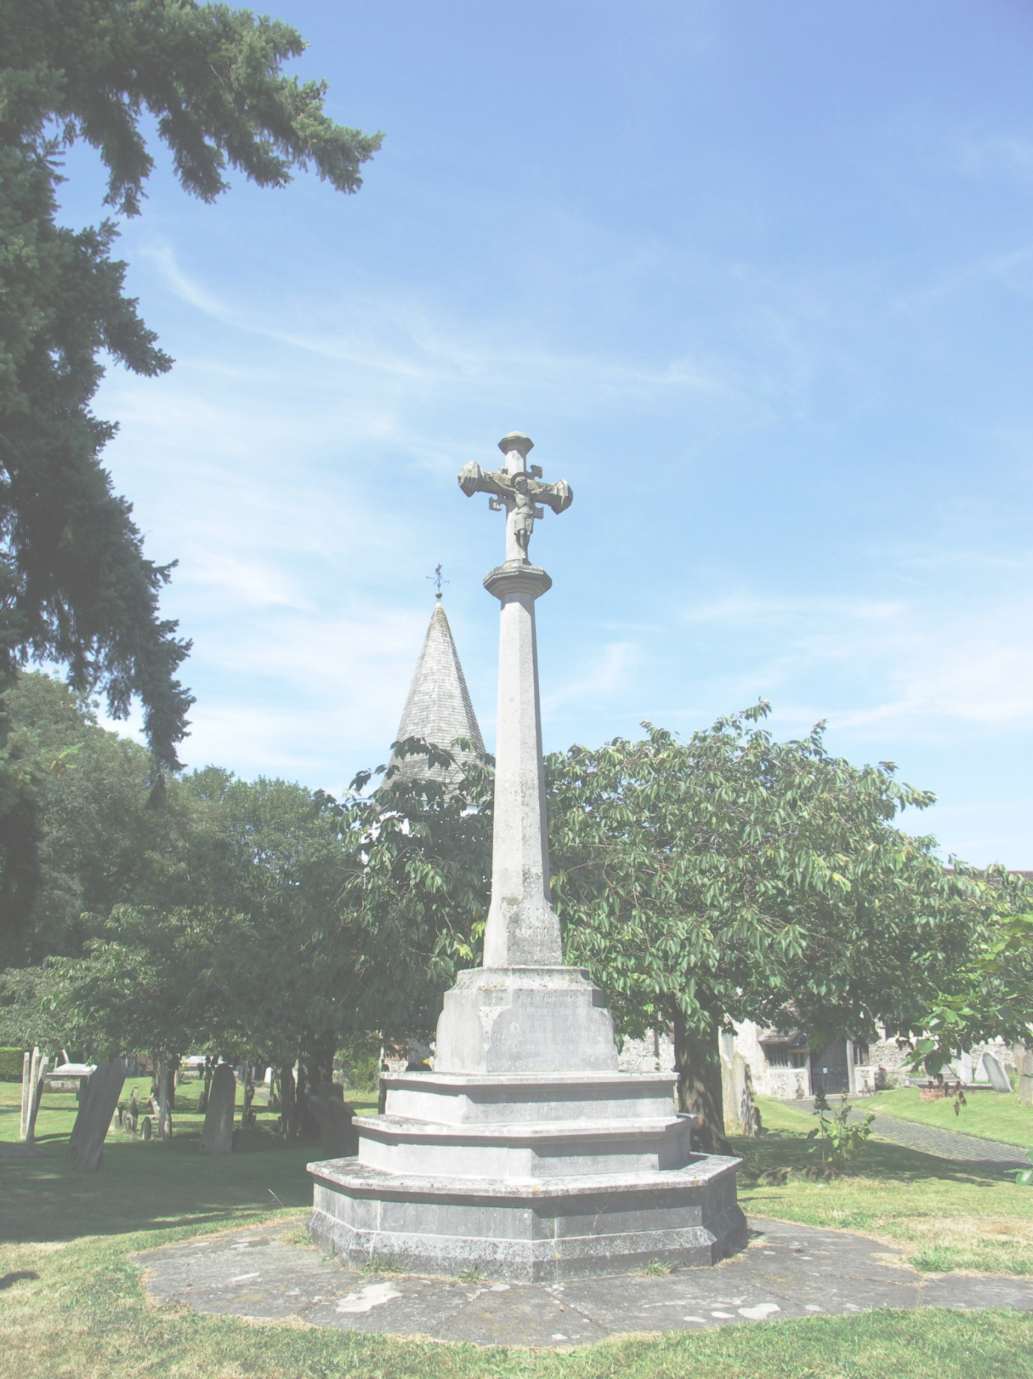
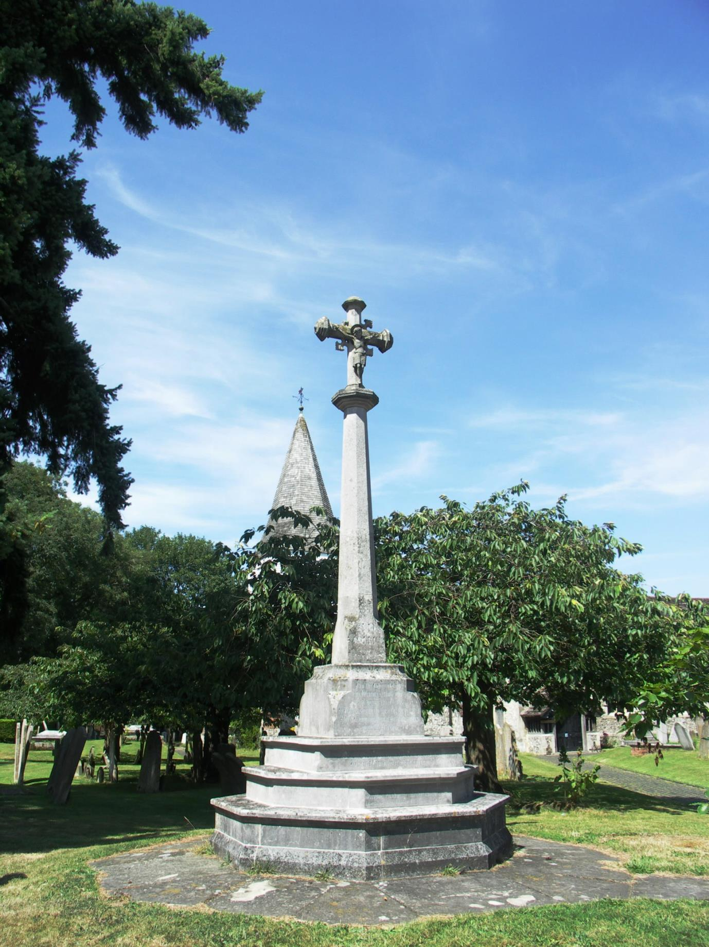

I.H.B.C SOUTH EAST BRANCH CPD SEMINAR

WAR MEMORIALS
-THEIR HISTORY, PROTECTION AND CONSERVATION

AS 2014 IS THE 100TH ANNIVERSARY OF THE OUTBREAK OF THE FIRST WORLD WAR, AND IN RECOGNITION OF THE FACT THAT MOST WAR MEMORIALS ARE NOW CONSIDERED WORTHY OF LISTING AS HERITAGE ASSETS, AN EVENING SEMINAR WILL BE HELD ON ALL ASPECTS RELATING TO WAR MEMORIALS IN THE SOUTH EAST AND BEYOND.

THE ILLUSTRATED TALK, FOLLOWED BY QUESTIONS, WILL BE GIVEN BY AMY DAVIDSON, CONSERVATION OFFICER WITH THE WAR MEMORIALS TRUST.

DATE: 7PM, WEDNESDAY 10TH SEPTEMBER 2014.

VENUE: WESTERHAM VILLAGE HALL, QUEBEC AVENUE, WESTERHAM, KENT, TN16 1BG.

COST: FREE, BUT DONATIONS TO THE WMT INVITED, REFRESHMENTS PROVIDED.

TO BOOK A PLACE CONTACT PETER MILLS BY EMAIL: peter.mills@molevalley.gov.uk OR BY PHONE: 01306 879192

GREAT BOOKHAM WAR MEMORIAL, SURREY GRADE II

REGISTERED OFFICE: 3 Stafford Road, Tunbridge Wells, Kent TN2 4QZ
Registered as a charity: No. 1061593
Company limited by guarantee: reg. in England; No. 3333780

