IHBC Annual School Carlisle 20-22 June 2013
As a recent graduate of the MSc in Historic Conservation from Oxford Brookes University, this year’s annual school, with a focus on Skills, was of particular interest to me as the masters course put a great emphasis on the importance of sustaining heritage skills. I was fortunate enough to be awarded a bursary to attend the full school which meant I was able to attend one of the Thursday afternoon tours. I joined the Historic Carlisle city tour led by Carlisle-born architectural historian, John Grundy. The tour covered almost the entire city and ended on the roof of the council offices where we were treated to a spectacular view of Carlisle and Cumbria. We received a fantastic commentary by John whose enthusiasm for the city went unabated all afternoon – and also well into the evening when he delivered the guest speech at the evening reception at the Tullie House Museum.
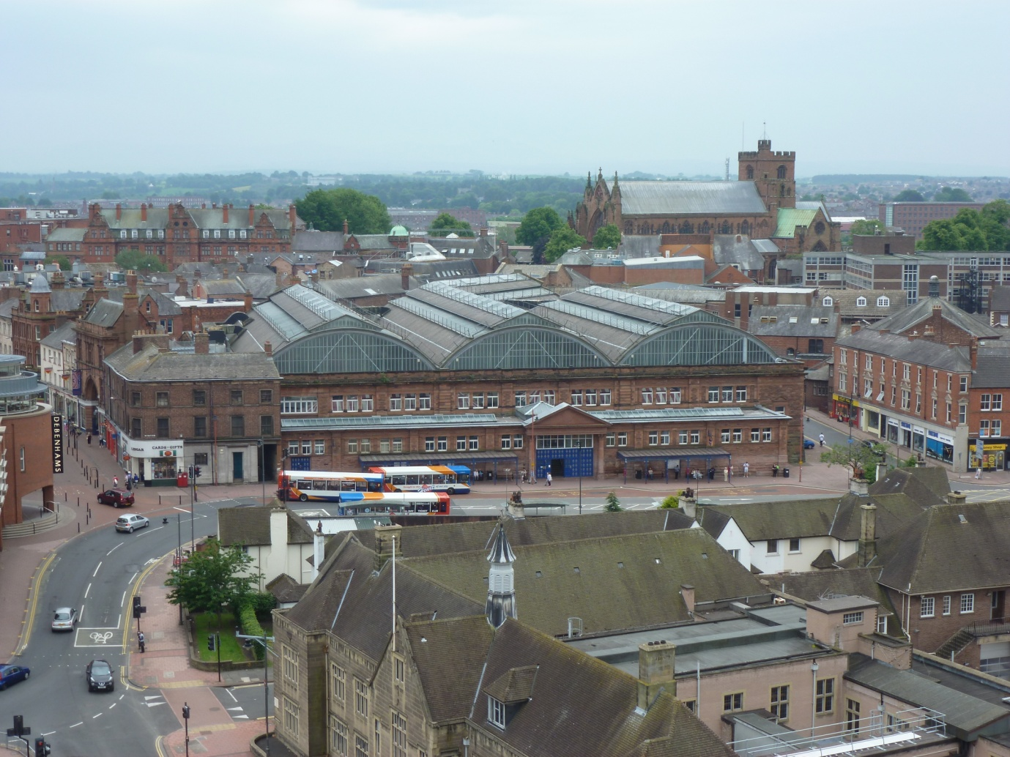
The view across Carlisle from the council roof towards the Cathedral and the Crown and Mitre Hotel

The day school on Friday provided us with a fascinating examination of the current situation regarding conservation skills. What was particularly interesting was the many ways that skills could be incorporated into good conservation practice, from supporting heritage skills under threat to utilising new technological skills to enhance conservation.
Our morning began with a discussion of resources for skills and skills development. Of note was the recent HLF project in Norfolk providing valuable skills training to new millwrights; this highlighted one of the ways that HLF projects can support the development of local skills-based projects.
Alan Gardner’s talk after lunch provided a new take on the important role that skills can take in conservation projects. In particular, the way skills can support local people and provide meaningful community outreach in practical ways. This was followed by Colin Haylock’s talk on the role of education in supporting skills.
In the afternoon, the important role the National Apprenticeship Service has in supporting professional skills development was outlined by Phil Bell. The use of digital technology in conservation was demonstrated by James Hepher from Historic Scotland and was an impressive display of how new skills are creating detailed pictures of our historic buildings. The scan made of the conference room amazed us all, particularly the speed at which the image was produced.
Friday evening provided us with a fantastic dinner from the Crown and Mitre Hotel and a chance to celebrate the success of this year’s Gus Astley award winners. This was particularly nice for me as two of this year’s winners were former Brookes students, one of whom completed the course the year before myself, which gave us even greater cause for celebration!
After a lovely evening socialising in Carlisle, our last day at the school was a mix of tours and skills workshops. I was lucky enough to visit some of the incredible clay buildings on the Solway Plain and a huge thank you from all those on this tour goes to both Peter Messenger, our tour guide, and to the kind people who allowed us into their houses to see the beautifully restored clay dabbins and those undergoing conservation. We were fortunate to visit a barn restored through community engagement and compare the historic clay walls with some newly repaired ones and to see a fantastic large barn that was the focus of a residential development. It was tastefully converted with a mezzanine level which ensured the survival of the character of the building and revealed the fantastic timber framing hidden within.
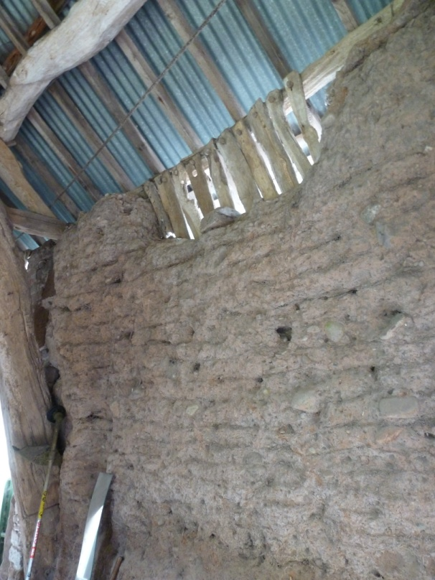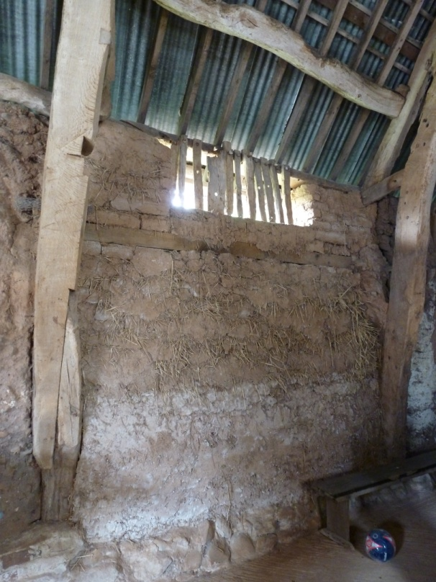
Original clay dabbins (L) and recently restored wall (R)

There was also a heritage skills fair run by the National Heritage Training Group on Saturday in the square outside our hotel. This was a brilliant display of heritage skills including lime working, blacksmithing, stone carving, pole lathing and lead working which some of us were able to try out. I myself carved a flower into a rather large piece of Lowther stone and have a whole new appreciation for the strength of stone carvers as my arms were exhausted by the end and we were working some fairly soft stone!
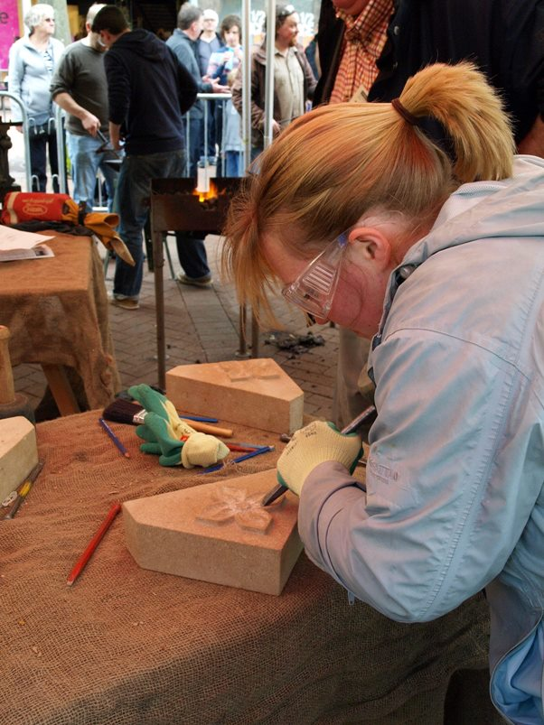
Stone carving at the NHTG skills fair (courtesy of Claire Gayle)

The entire school was a great opportunity to network with other professionals from all over the country, in particular from Scotland and North England, which being a born and bred Southerner I don’t get the chance to do very often! The skills theme was brilliantly carried over the entire school and by the exhibitors at the day school. A huge thank you goes to everyone involved in organising a brilliant school and ensuring the smooth running of the whole three days from the people who met us at the station to those who ensured there was plenty of tea and coffee in the breaks! I think we’re all looking forward to Edinburgh next year; they have a lot to live up to!

