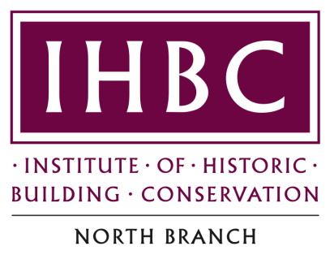

Minutes

of the

Tenth Annual General Meeting

held on

Tuesday 19th October 2012

Present: Stewart Ramsdale (Chairman), Mike Hein-Hartmann, Ken Hutchinson, Ian Goodman, David Lovie, Ian McCaffery, Richard Majewicz, Jules Brown, Naomi Atherton, Wenda Fabian, Michael Atkinson, Roger Higgins, Val Robson, Sarah Dyer, Alan Hunter, Vladimir Ladinski, Geoff Underwood, Ian Wells, Sonia Kempsey, Clare Lacey, Mary Richardson, Elizabeth C. Marsh, Nicola Harrison, Phil Lloyd and Michael Hurlow.

Welcome

Stewart Ramsdale welcomed everyone to the tenth Annual General Meeting of IHBC North Branch

Apologies

Graham Darlington.

Minutes of the Ninth Annual General Meeting

The minutes of the ninth AGM held on Thursday 15 October 2009 at Bowes Museum, Barnard Castle, were agreed as a true record.

Matters Arising

There were none.

Treasurer’s Report

Mr Hein-Hartmann reported that the balance stood at £388. The branch bank account was transferred to Lloyds early in 2012, in order to avoid bank charges.

Review of the year by the Chairman

- Only two branch committee meetings were held to date in 2012. All members are welcome to attend meetings.

- The focus of the year’s activities was the preparations for hosting the 2013 Annual School in Carlisle. Venues and accommodation are in the process of being booked. Most of the speakers have been booked. Options for study tours and day-school case studies have been identified but are yet to be finalised. A number of trade stands have been secured and support has been secured from diverse sources to promote the School. Sponsors are being approached but more contacts are required with regional agencies & businesses.

- Since the last AGM, Ian McCaffery and Ken Hutchinson took on responsibility for editing and publishing the branch newsletter meeting the target two editions p.a.

Election of Branch Committee

Mr Ramsdale reported that since the last AGM in 2009 the following changes had taken place:

- Elaine Hogg was replaced by Val Robson as Branch Secretary;

- David Lovie, Clare Lacy and Graham Darlington have left;

- Richard Majewicz, Naomi Atherton, Michael Atkinson and Lee Wall have been co-opted;

- Alan Hunter was nominated as English Heritage’s representative on branch committee.

Mr Lovie proposed, Mr McCaffery seconded and members voted unanimously to re-elect the existing committee members as follows: -

Stewart Ramsdale, Geoff Underwood,
Mike Hein-Hartmann Ian Goodman
John Pendlebury Ken Hutchinson
Ian McCaffery David Carruthers
Ian Goodman John Pendlebury

Nominations received for election to branch committee were as follows: -
Val Robson Richard Majewicz
Naomi Atherton Michael Atkinson
Lee Wall Jules Brown
Sarah Dyer

Mr Hutchinson proposed, Mr Hein-Hartmann seconded and members voted unanimously to elect the above persons to serve on branch committee.

Election of Branch Chair

Having served for nearly 11 years as branch chair, Mr Ramsdale decided to stand down. There were no nominations for branch chair and so the post was left vacant.

Election of Branch Officers

Ms Dyer proposed, Mr Atkinson seconded and members voted unanimously to elect the following branch officers:
- Branch Representative on National Council: Geoff Underwood
- Branch Secretary: Val Robson
- Branch Treasurer: Mike Hein-Hartmann
- Cumbria Representative: Richard Majewicz

Any other business

There was none.

